Banking Analytics: Customer Segmentation & Risk Insights
Report

1. Project Overview
This project analyses a banking dataset using Python, MYSQL and Power BI to understand customer behavior, loan distribution, deposit trends, and overall financial performance. The dashboard provides insights into key banking metrics such as total loans, deposits, customer segmentation, and income distribution.

2. Business Problem Statement
The bank is managing large volumes of loans and deposits but lacks clarity on:
- Which customer segments drive revenue
- Risk distribution across loan categories
- Deposit vs loan balance efficiency
- Customer demographics impact (gender, income, nationality)

2.1 Dataset Overview
The dataset contains 3000 customer records from a banking system, with 25 variables capturing demographic, financial, and behavioural information.
It includes both categorical variables (e.g., Occupation, Nationality, Loyalty Classification) and numerical variables (e.g., Income, Deposits, Loans).
Column Categories
(a). Customer Demographics
- Age
- Nationality
- GenderId
(b). Banking Relationship
- Joined Bank
- Loyalty Classification
- Fee Structure

(c). Financial Information
- Estimated Income
- Bank Deposits
- Bank Loans
- Credit Card Balance
(d). Account Details
- Checking Accounts
- Saving Accounts
- Foreign Currency Account
(e). Risk & Assets
- Risk Weighting
- Properties Owned
The dataset captures customer behavior across multiple dimensions including demographics, financial strength, asset ownership, and risk classification.

3. Objectives
- Analyse total loans and deposits
- Identify high-value customer segments
- Evaluate loan distribution across income bands
- Understand demographic impact on banking products
- Provide insights for risk and growth optimization

4. Key Insights from Dashboard
4.1 Overall Performance (Home)
- Total Clients: 3000
- Total Loan: $4.4bn
- Total Deposit: $3.77bn
- Checking Accounts: 963M
- Saving Accounts: 699M
Insight: Loans exceed deposits → potential liquidity risk

4.2 Loan Analysis
- Private Bank contributes highest loan (~814M)
- Retail and Commercial segments follow
- Medium income group dominates (53%)
Problem: Loan concentration in specific segments increases risk exposure

4.3 Deposit Analysis
- Private Bank leads deposits (~925M)
- Medium income group contributes majority (~54%)
Problem: Over-dependence on mid-income customers

4.4 Demographic Insights
- European customers dominate both loans and deposits
- Occupation categories show uneven distribution
Problem: Lack of diversification across customer base

5. Key Business Problems Identified
- Loan > Deposit imbalance (Liquidity Risk)
- High dependency on medium income customers
- Concentration risk in Private Banking segment
- Limited diversification across nationality & occupation
- Potential credit risk due to uneven loan distribution

6. Recommended Solutions
6.1 Improve Deposit Mobilization
- Introduce high-interest savings schemes
- Target new customer segments
6.2 Diversify Loan Portfolio
- Expand lending to underrepresented segments
- Reduce dependency on private banking
6.3 Risk Management Strategy
- Monitor high loan concentration
- Implement stricter credit policies
6.4 Customer Segmentation Strategy
- Target low- and high-income groups
- Personalize financial products
6.5 Market Expansion
- Focus on underrepresented nationalities
- Increase outreach campaigns

7. Dashboard Overview
7.1 Home Dashboard
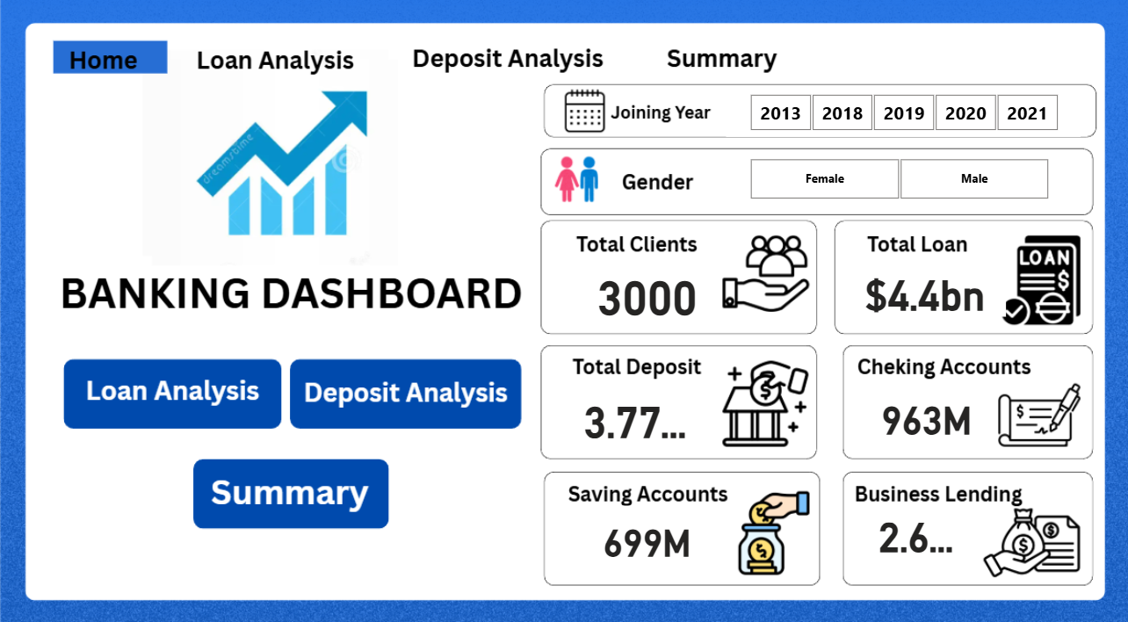
Caption: This dashboard Shows the Overview of key banking KPIs including total clients, loans, deposits, and account balances.

7.2 Loan Analysis Dashboard
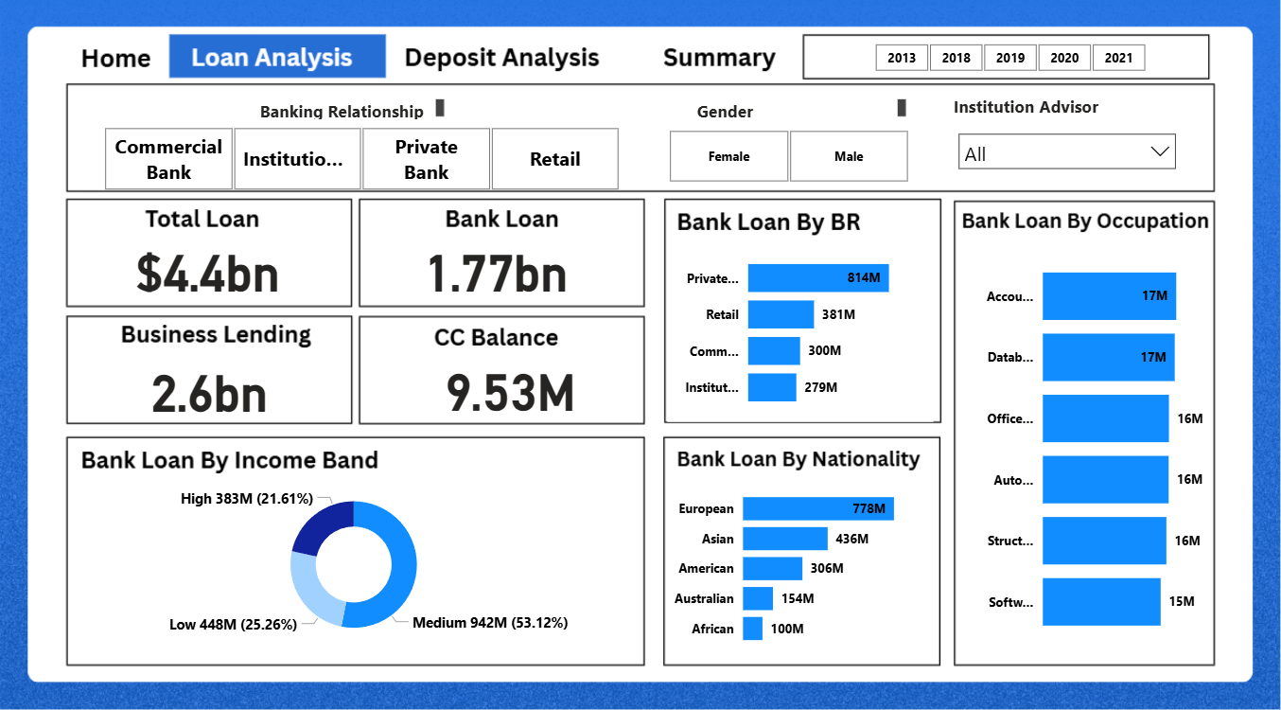Caption - This dashboard analyses loan distribution across banking relationships, income groups, and customer demographics to identify key lending patterns

7.3 Deposit Analysis Dashboard
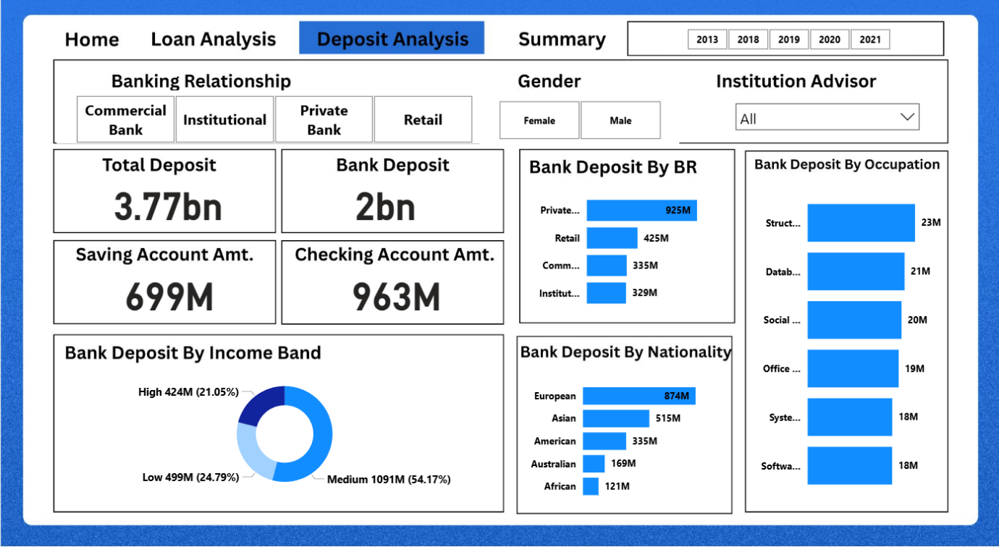Caption: This dashboard analyses bank deposit distribution across banking relationships, income groups, and customer demographics to identify key lending patterns.
7.4 Summary Dashboard
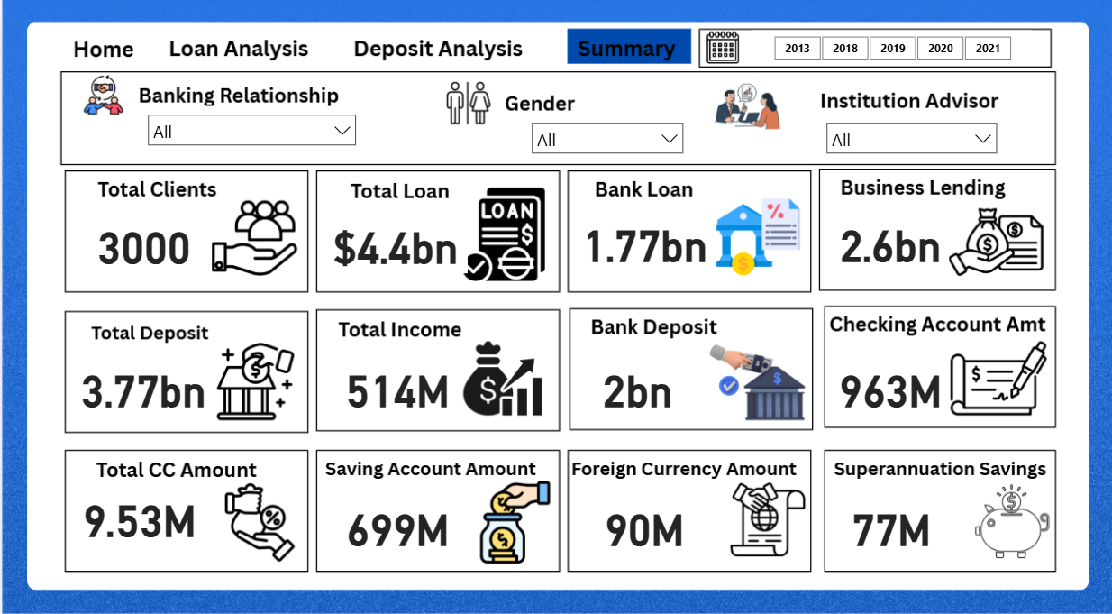
Caption: This dashboard Shows the summary of key banking KPIs including total clients, total loans, total deposits, total income, bank deposit, Saving Account Amount and Superannutation Savings.

7.5 Loan by Income Band
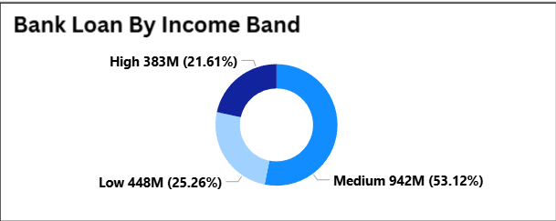
Caption: “Medium-income customers account for the majority of loan distribution (~53%), while high-income customers contribute only ~22%. This indicates a strong reliance on the mid-income segment, creating an opportunity to expand lending toward high-income customers. Diversifying into this segment could help reduce customer concentration risk and improve portfolio balance.”
7.6 Deposit by Income Band
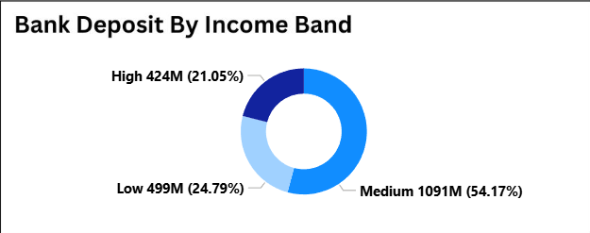
Caption: “Medium-income customers account for the majority of bank deposits (~54%), while high-income customers contribute only ~21%. This indicates a strong reliance on the mid-income segment, creating an opportunity to expand savings accounts facility toward high-income customers by offering them handsome interest rate. Diversifying into this segment could help reduce customer concentration risk and improve portfolio balance.”.

7.7 Loan by Banking Relationship
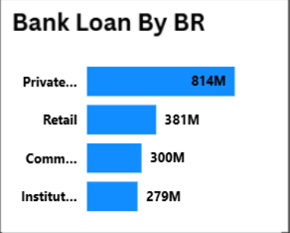
Caption: Private Institutions accounts for majority of loan (815M) followed by Retail(381M), Commercial(300M) and Other Institutions(279M). This shows a strong dependence on Private institution for loans.

7.8 Deposit by Banking Relationship
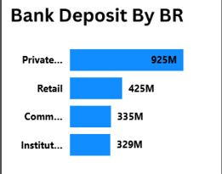
Caption: Private Institutions accounts for majority of deposit (925M) followed by Retail(425M), Commercial(335M) and Other Institutions(329M). This shows a strong reliable on Private institution for deposit. Bank should target other segment of customers and encourage them to save more in accounts.

8. Tools Used
- MS Excel
- SQL
- Power BI
- Python

9. Conclusion
The banking analysis highlights critical issues such as liquidity imbalance, customer concentration, and portfolio risk. By improving deposit strategies, diversifying loan distribution, and targeting new customer segments, the bank can achieve sustainable growth and reduce financial risk.

